Belbin Roles
Validation and Reflection
Purpose
This reflection helps you understand how you contribute to a team based on your Belbin profile. It also supports you in developing flexibility by exploring roles beyond your natural preferences.
Note: Belbin roles are not fixed personality traits. They are roles (“hats”) you can adopt depending on the situation. Your profile shows your natural tendencies, not your limits.
Please copy your Belbin Roles Results here

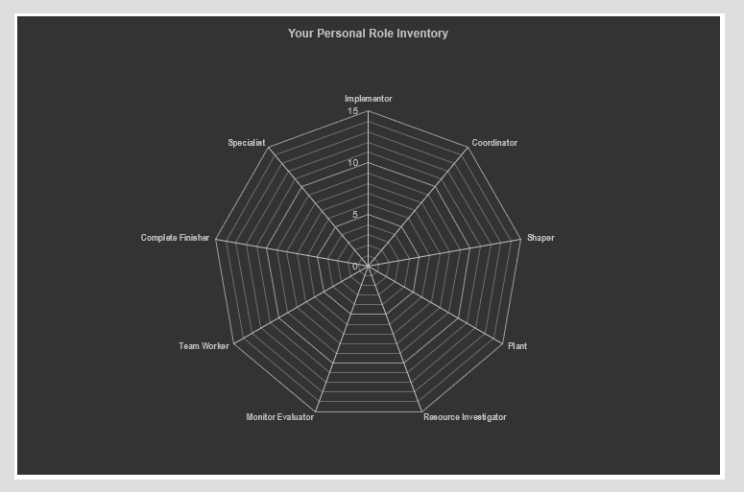

1. Recognition & Evidence
To what extent do your highest scores in the Belbin spider diagram match your own perception of how you contribute to a team?
Which roles feel most recognizable to you?
Which roles surprised you (if any)?
Provide at least TWO concrete examples (artifacts or moments):
Example 1:
What happened?
What did you do?
Which role did you demonstrate?
Example 2:
What happened?
What did you do?
Which role did you demonstrate?

2. Strengths and Allowable Weaknesses
Belbin suggests that every strength comes with an allowable weakness (e.g., a Plant may overlook details).
Describe a situation where you may have overused one of your strong roles:
Which role was it?
What behavior did you show?
What was the negative effect on the team or outcome?
Reflection:
How did you respond to this situation?
What could you do differently next time?

3. Deeper Reflection: Your Role in a Team
a. Role Orientation
Do you see yourself more in:
- ☐ Action-oriented roles
- ☐ People-oriented roles
- ☐ Thinking-oriented roles
Explain your choice:

b. Working Preferences
How does your Belbin profile influence how you prefer to work in a team?
Think about:
- Structure vs. flexibility
- Independence vs. collaboration
- Planning vs. improvisation
Your reflection:

c. Optimal Team Environment
What kind of team environment helps you perform at your best?
Think about:
- Communication style
- Level of structure
- Feedback culture
- Role clarity
Your reflection:

References
- Aguilar Vera, R. A., Díaz Mendoza, J. C., Muñoz-Mata, M. A., & Ucán Pech, J. P. (2020). Influence of Belbin’s Roles in the Quality of the Software Requirements Specification Development by Student Teams. In Advances in Intelligent Systems and Computing (Vol. 1061). Springer.
- Flores Ureba, S., Simón de Blas, C., Borrás-Gené, O., & Macías-Guillén, A. (2022). Analyzing the Influence of Belbin’s Roles on the Quality of Collaborative Learning for the Study of Business Fundamentals. Education Sciences, 12(9), 594.
- Smith, M., Polglase, G., & Parry, C. (2012). Construction of Student Groups Using Belbin: Supporting Group Work in Environmental Management. Journal of Geography in Higher Education, 36(4), 585–601.

1. Recognition & Evidence
To what extent do your highest scores in the Belbin spider diagram match your own perception of how you contribute to a team?
Which roles feel most recognizable to you?
Which roles surprised you (if any)?
Provide at least TWO concrete examples (artifacts or moments):
Example 1:
What happened?
What did you do?
Which role did you demonstrate?
Example 2:
What happened?
What did you do?
Which role did you demonstrate?

